**1223 FST**

Practical Project 1: Mobile Applications Development

GROUP COURSEWORK

Assignment One

GROUP 1 MEMBERS

1. EDGAR TINKAMANYIRE VU-BCS-2209-0128-EVE
2. DANIEL BECH MAKER VU-BCS-2201-1664-DAY
3. WASSWA JOSEPHSON VU-BCS-2201-0546-DAY
4. HUSSEIN NAGASHA VU-BCS-2201-0484-DAY
5. NAKIDEL YAMINE BEN VU-BCS-2201-0184-DAY
6. Table 1

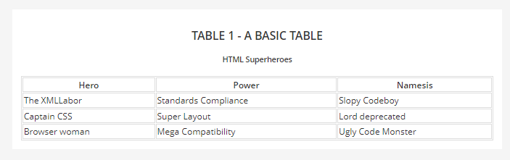

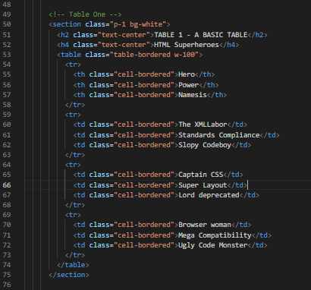

1. 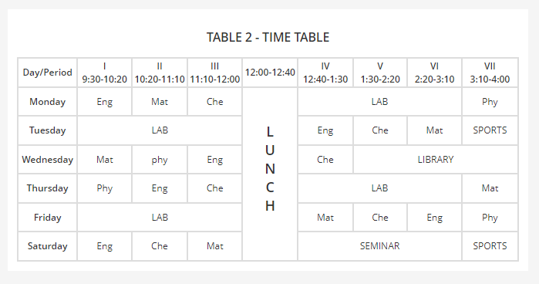Table 2

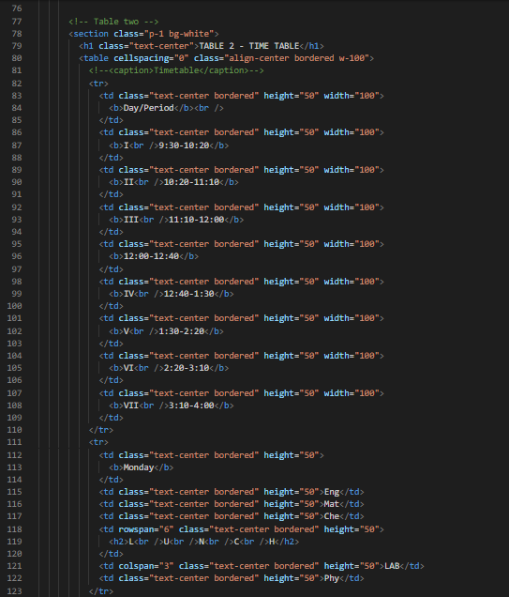

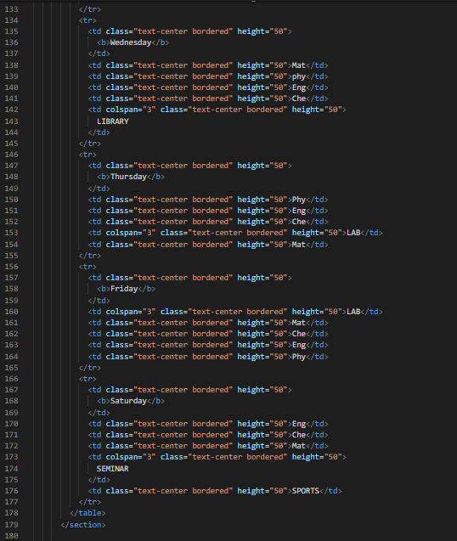

1. Table 3

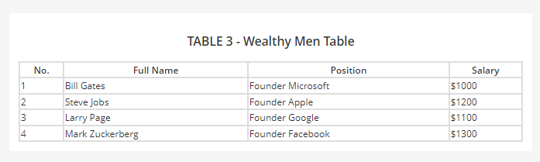

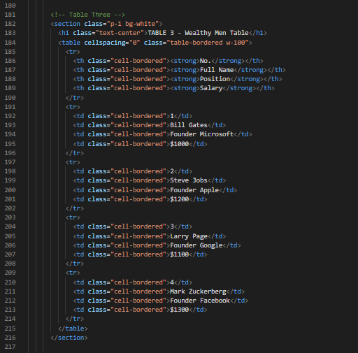

1. 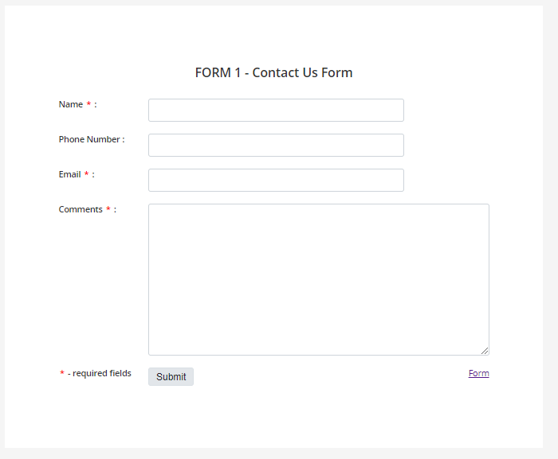Form 1 – Contact Form

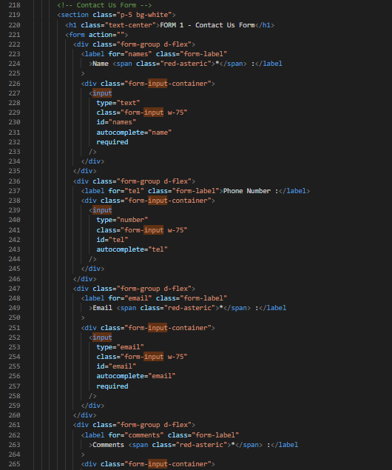

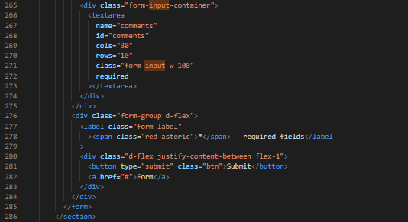

1. Form 2 – Login Form

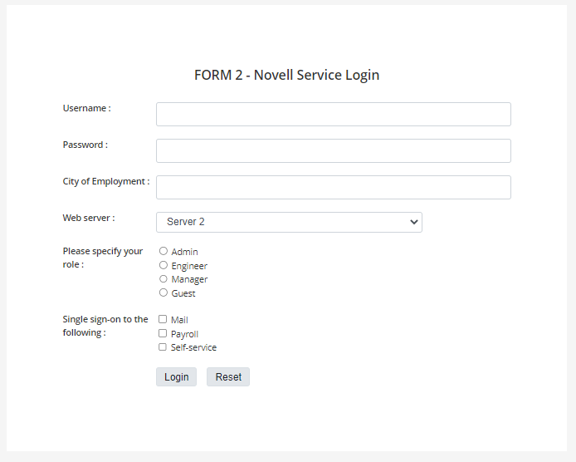

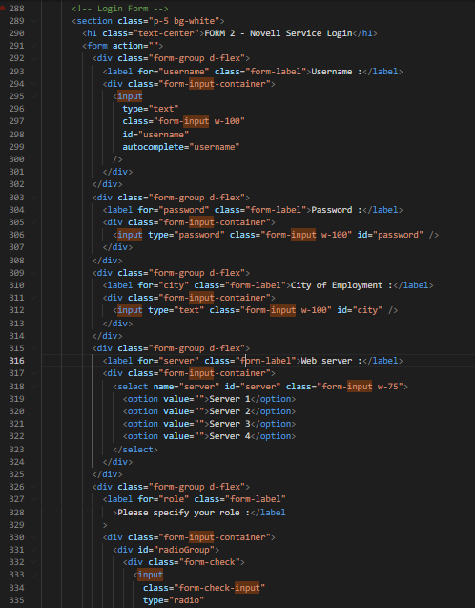

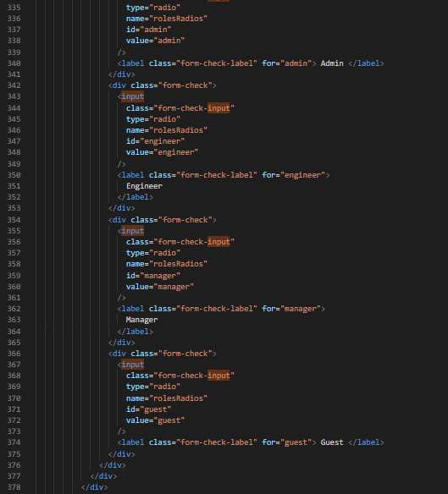

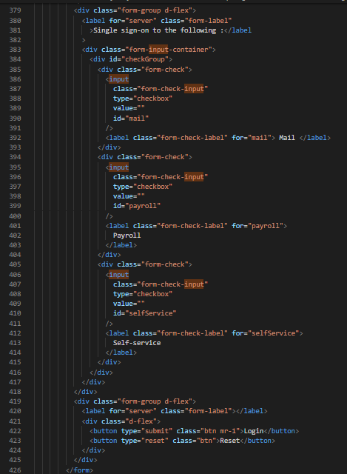

The CSS File

We are using external CSS that is imported through the head.

